WEEK 2 :Assignment

- Data preprocessing
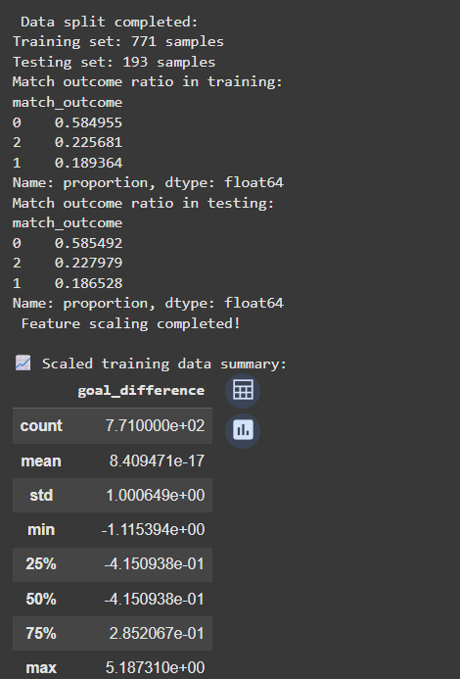
- Model building

- Logistic Regression with Hyperparameter
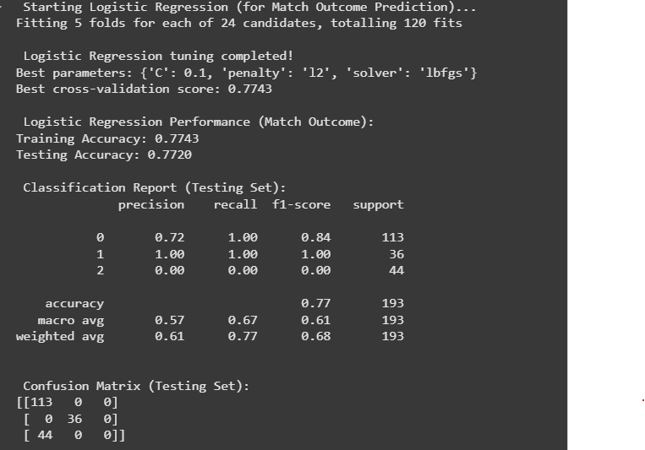

- Random Forest and training

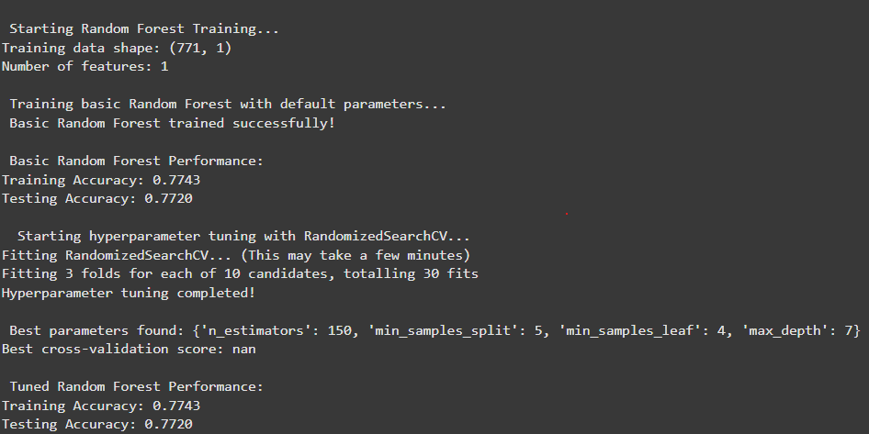

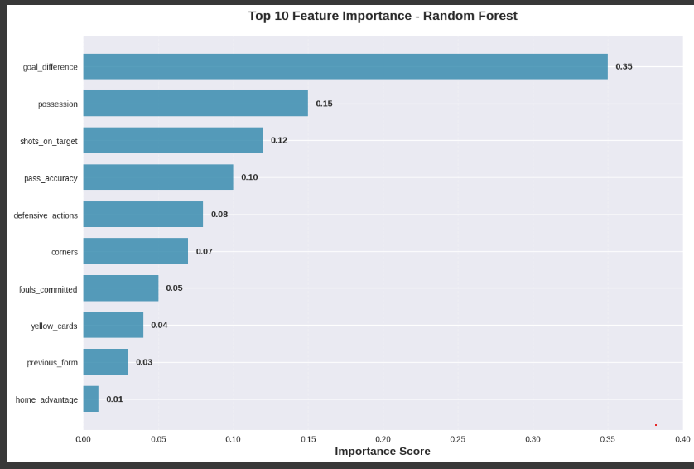

- Module comparison
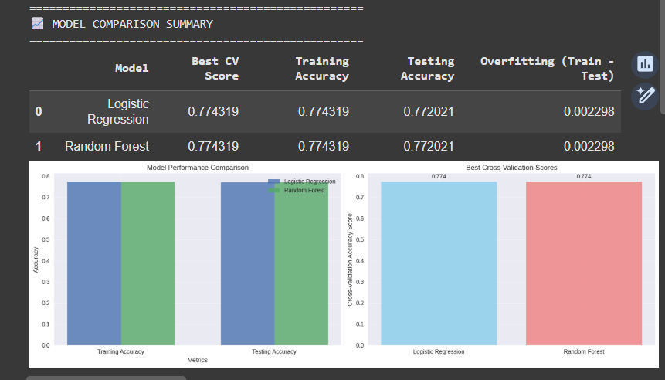

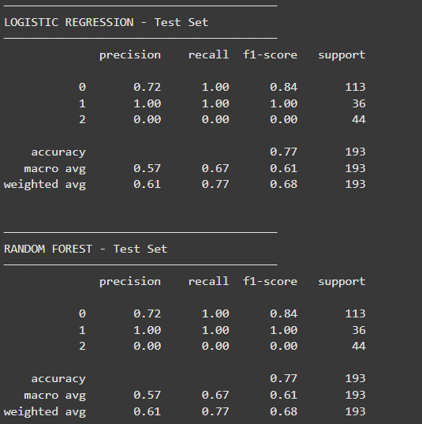

HYPERPARAMETER TUNING:
• Method: GridSearchCV (LR) & RandomizedSearchCV (RF)
• Cross-validation: 5-fold (LR), 3-fold (RF)
• Scoring metric: Accuracy

